Final Project: Proposal
Elijah McCauley, Osborn Wang, Zhixin Wang
Context & Problem Motivation
The New York City subway system is the circulatory system of the city, handling millions of riders daily. However, station crowding and passenger volume are highly volatile. While general rush-hour trends are predictable, actual hourly ridership at specific stations is heavily influenced by exogenous factors such as sudden weather shifts, localized events, and temporal anomalies; a sudden rainstorm, a heatwave, or a weekend disruption can instantly drive thousands of unexpected riders underground, overwhelming specific stations. Currently, station staffing, security deployment, and supplementary transit rebalancing (such as bus availability) often operate on static schedules. This reactive approach leads to severe shortcomers, safety hazards during unexpected surges, and inefficient resource allocation during quiet periods.
In the context of urban public policy, accurately forecasting station-level volume is critical for dynamic resource management. This project proposes a predictive analytics approach to model hourly MTA station ridership. By leveraging machine learning techniques to map the complex, non-linear relationships between external factors like precipitation, temperature, time of day and some specific hotspot station volume (Time Square, WTC, 14-St, etc.), we aim to demonstrate how data-driven forecasting can optimize urban infrastructure, improve commuter experience, and enhance the overall efficiency of public transit operations. Solving this problem is highly impactful for urban planning, as accurate predictive models could allow city agencies to proactively manage staff control, reroute supplementary transit, and significantly improve the daily flow of the city.
Data
- Core datasets:
  - MTA Subway Hourly Ridership 2022 to 2024: This dataset records the hourly turnstile counts and ridership data for the NYC subway system. https://www.kaggle.com/datasets/yaminh/mta-subway-hourly-ridership-2022-to-2024
  - Official NY Open Data (primary sources): https://data.ny.gov/Transportation/MTA-Subway-Hourly-Ridership-2020-2024/wujg-7c2s/about_data, https://data.ny.gov/Transportation/MTA-Subway-Hourly-Ridership-Beginning-2025/5wq4-mkjj/about_data
- The core datasets are filtered under the conditions of:
- transit_mode is subway
- borough is Manhattan
- timestamp: from 2022-05-15 to 2024-05-20, or 2025-01-01 to 2026-02-28.
- Station_complex_id based on selected transportation hub:
Hub Name | Station Complex | station_complex_id
World Trade Center | Chambers St (A,C)/WTC (E)/Park Pl (2,3)/Cortlandt (R,W)  WTC Cortlandt (1) | 624 & 328
Fulton Center | Fulton St (A,C,J,Z,2,3,4,5) | 628
Grand Central | Grand Central-42 St (S,4,5,6,7) | 610
Penn Station | 34 St-Penn Station (A,C,E)  34 St-Penn Station (1,2,3) | 164 & 318
Times Sq / PABT | Times Sq-42 St / 42 St-Port Authority (A,C,E,N,Q,R,W,S,1,2,3,7) | 611
Herald Square | 34 St-Herald Sq (B,D,F,M,N,Q,R,W) | 607
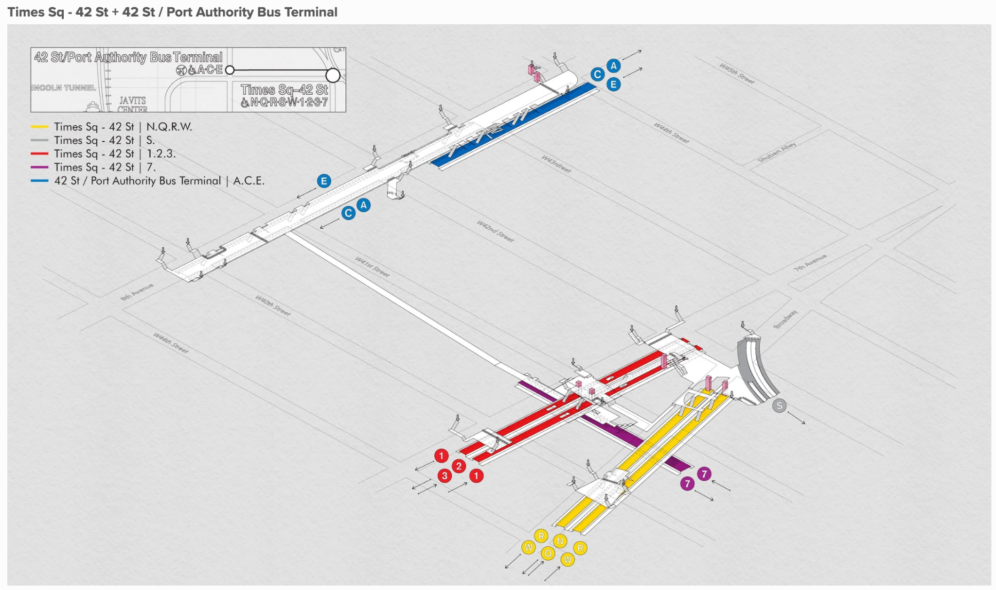
- Outcome variable: ridership (total number of riders that entered a subway complex at the specific hour).
- Related features & supplement datasets:
  - Temporal features: Year, Month, Hour of Day, Day of Week/Is weekend, Season, Holiday, Is NYC School Day (Derived from transit_timestamp in the core dataset).
  - Lagged features: Ridership lag 1h/24h.
  - Weather:
    - Precipitation (Rain/Snow), Temperature:
https://www.wunderground.com/history/monthly/us/ny/new-york-city/KLGA/date/2023-1
Air quality (AQI): https://data.cityofnewyork.us/Environment/Air-Quality/c3uy-2p5r/about_data, https://a816-dohbesp.nyc.gov/IndicatorPublic/data-features/realtime-air-quality/
  - MTA fare:
    - January 4, 2026: $3.00
    - August 20, 2023: $2.90
    - March 22, 2015: $2.75
    - March 2013: $2.50
Proposed Methods
Data Preprocessing and Baselines
Data Preprocessing and Baselines We will align our multi-source external data to hourly reporting intervals, standardize continuous variables, and encode cyclical temporal features (Hour, Day of Week) using sine and cosine transformations. To establish a performance baseline, we will calculate a historical average heuristic and fit an unregularized Ordinary Least Squares (OLS) regression to quantify the variance explained purely by standard commuter cycles.
Predictive Modeling
- Time Series Analysis: We will deploy time series forecasting techniques to explicitly model the temporal dependencies, lagged effects, and cyclical seasonality inherent in urban transit data.
- Ensemble Benchmarks: Random Forest models will be trained to capture non-linear commuter behaviors and automatically establish a feature importance hierarchy among our supplementary variables.
- Neural Networks: Deep learning architectures will be utilized to natively capture the complex, high-dimensional interactions between our exogenous factors (e.g., weather, temporal anomalies) and localized volume surges.
Evaluation and Failure Mode Analysis Models will be evaluated using Mean Absolute Error (MAE), Root Mean Squared Error (RMSE), and Weighted Mean Absolute Percentage Error (WMAPE) to ensure unpredictable ridership spikes do not disproportionately skew the loss surface. Finally, we will conduct a rigorous failure mode analysis by examining our residual errors. By isolating specific timestamps and stations where our models severely mispredict volume, we aim to identify systemic blindspots, characterize remaining performance gaps, and propose data augmentations for future iterations.

Evaluation metrics: MAE, RMSE, WMAPE

